Project Management

Assessment ONE

John in wells college

|  |  |  |  |
| --- | --- | --- | --- |
| Name of Student | IRNANDI MULIAWAN | ID | 18073 |

**Assessment 1 – Case Study**

Contents

Instruction: 2

Duration: 2

Case Study: 2

Going Green application, Green IT Project Management 2

Project profile 2

Here is my software running on my phone! Or Access by: 4

Business situation 4

Your tasks: 5

Task 1: Identify Business Strategy and Gap 5

Analyse Strategy 5

Task 2: Recommend a feasible solution 6

Task 3: Produce a Project Charter 6

Task 4: Project Document 8

Task 5: Project Closure 9

Helpful web links to complete the assessment: 12

Search Index 13

## Instruction:

This task is to be completed individually. You need to analyse a case scenario and complete all the tasks mentioned after the scenario.

You need to demonstrate your IT project management ability to identify business strategy and gaps. You will also need to suggest a feasible solution to overcome identified gaps and produce a project charter along with a WBS to implement the proposed solution.

### Duration:

Trainer will set the duration of the assessment.

All my working could be checked at: <https://nandilagi.github.io/pjctmgt18073IrnandiT32022/>

## Case Study:

### Going Green application, Green IT Project Management

# Project profile

Going “Green” is a mission of many companies around the globe not just for reasons of environmental responsibility, but also for cutting costs in these extremely tight economic times. Green IT efforts represent a specific focus area within enterprises that hold attention to this trend. Green IT leverages information technology to streamline operations, cut costly waste, and reduce the impact on the environment. IT typically consumes only about 10% of an organization’s energy costs, but the net effect of a Green IT project is to go beyond just energy saving. To tackle the other 90%, a Green IT project extends into a variety of other departments, and to execute such an endeavour requires an effective project management function in order to identify and prioritize goals. A Green IT transformation can be a complex process.

Vital Statistics:

* Number of project tasks - 12
* Project duration - 16 months
* Project budget - $1,200,000
* Number of users - 50

## Your tasks:

### Task 1: Identify Business Strategy and Gap

Document the business’s strategies of “Green IT” and also summarise the components required changes for the participating organisation to implement “Green IT Project”. (Min. 300 words)

Answer:

Eco-friendly businesses have a strong edge in the market. Roughly a third of customers will [give priority to brands offering eco-friendly products](https://www.surveymonkey.com/curiosity/more-consumers-are-opening-their-wallets-for-eco-friendly-products/). The problem is that new green companies have difficulty getting their name out.

Search engine marketing is essential for green companies. It can be a dual-benefit as Huffington Post [pointed out in their article](https://www.huffingtonpost.com/brian-hughes/good-for-the-environment-_b_9435418.html) “Good the Environment Good for SEO?” which is quoted below:

“An eco-friendly business model is not just good for environment- going green can also give your digital marketing a boost, too… Just ask Reimer Ivang with Better World Fashion, an innovative startup creating sustainable leather jackets. After Better World Fashion “greened” their SEO strategy, they noticed a real jump in their Google rankings as well as an increase in visitor on-page time.”

Having a good environmental presence can benefit your SEO by helping you attract backlinks. However, you [need a good SEO strategy](https://blueandgreentomorrow.com/features/best-strategies-learning-top-secrets-seo/) to begin with so people can find your brand before earning those organic links. It is like the chicken and the egg dilemma.

**Choosing an SEO Solution as a Green Company**

A lot of green businesses are aware of the concept of SEO, along with its significance. However, their knowledge is only limited to keyword-based content creation based on the most searched topics. To be very frank, that task is arduous as well as ineffective. Major corporations have a decisive advantage over new green companies if the keyword is your only concern as they have a much larger number of backlinks and content updates.

It is also essential that the SEO practices are modified and evolved with time. Most green businesses fail to follow through with their SEO practices. After all, eco-friendly businesses tend to be newer and less experienced business people usually make the decisions. It would give you a great edge if you know [how to manage your SEO well](https://blueandgreentomorrow.com/business/7-green-business-ideas-for-eco-minded-entrepreneurs/).

**Modern SEO Strategy:**

A good SEO strategy for any green business involves organizing a website’s content based on its topic. Based on this, Google can cater better to searcher’s needs and subsequently improve the websites ranking.

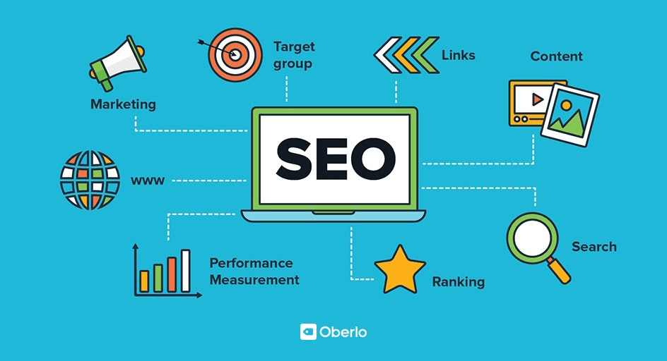

### Task 2: Recommend a feasible solution

Assume “Wells International College” is thinking of going “Green” and asked for your assistance in this project. Research different project management applications on the Internet to compare with the Green IT project management application and recommend a feasible solution with proper reasons for Windsor. (Min. 300 words)

Answer :

In the online marketing world, search engine optimization acts as an effective marketing strategy with the main focus to increase the business' reach to the target customers. SEO plays a crucial role in digital marketing campaigns and it has become an inseparable part of the digital marketing industry.

This table shows that SEO currently one of a trend that will lead to the objective alongside with the company

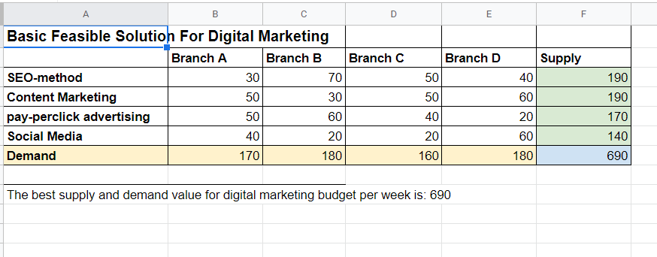

### Task 3: Produce a Project Charter

Please view my project charter (here only show part):

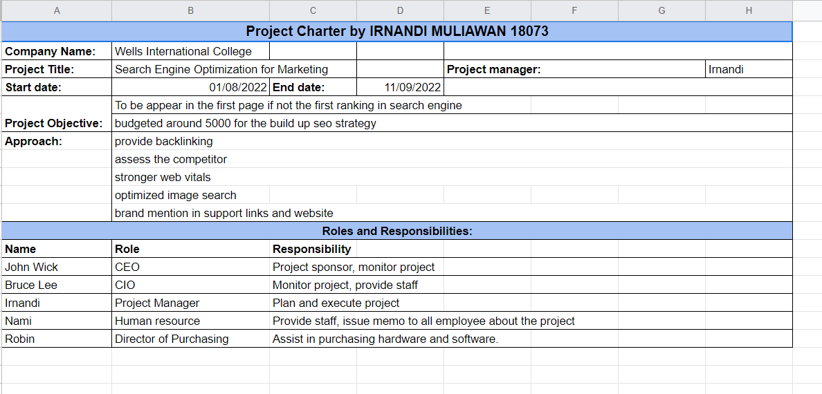

### Task 4: Project Document

Please check my site: <https://nandilagi.github.io/pjctmgt18073IrnandiT32022/>

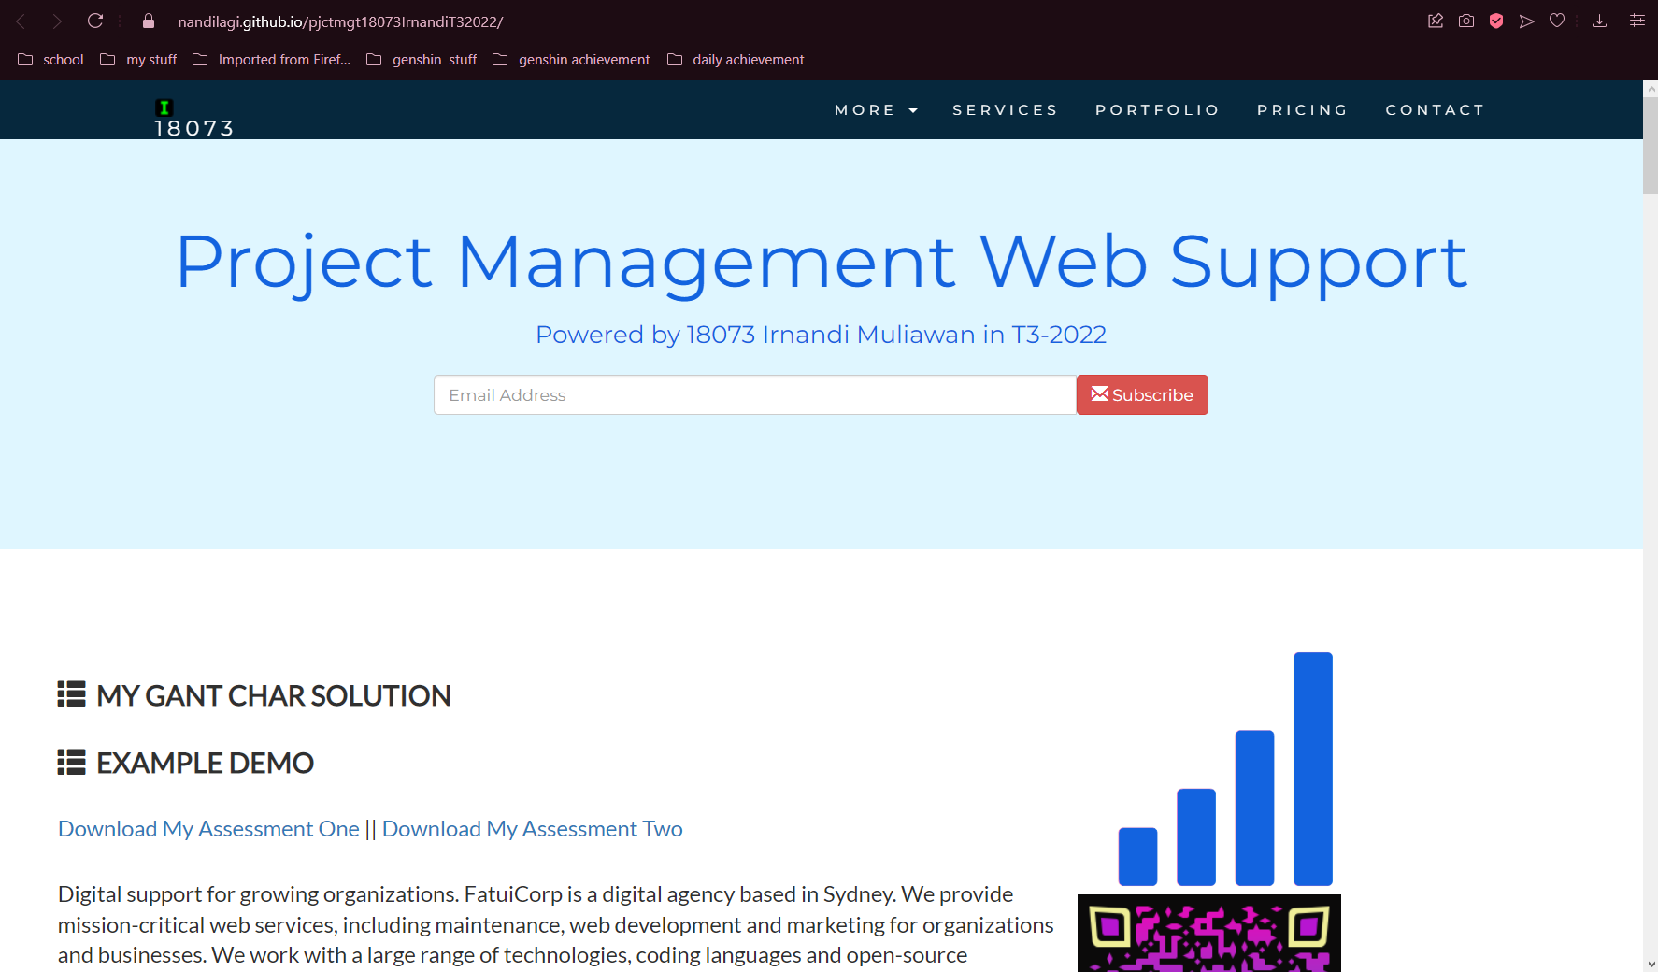

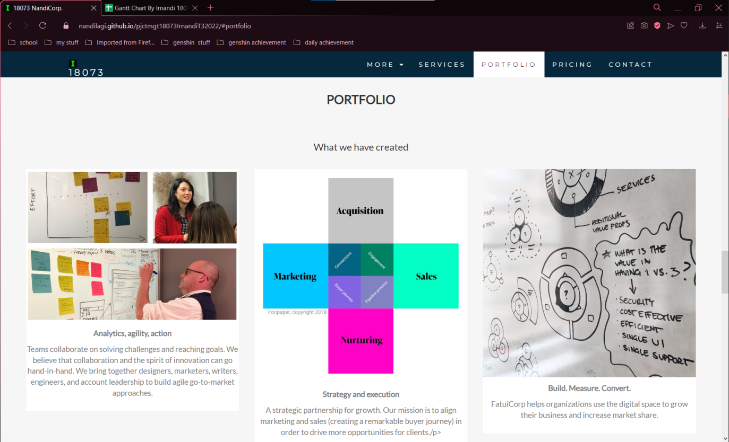

Refer to your current project, you have been asked to develop a project plan for WIC. Project plan outline as following:

In my Green project, I design following topics:

* Introduction

SEO is the process of helping your website rise in rank on Google and other search engines, therefore getting your site in front of more people, increasing business and making you an industry leader. It is extremely important that you have a solid strategic plan before you dive in

* Project background

For content marketing, an SEO strategy is a critical piece of the puzzle because it is how your content will come to be seen in the first place, especially in search engine result pages (SERPs). If your content is scattered and unorganized, search engine bots will have a harder time indexing your site, identifying your area of authority, and ranking your site pages.

* Related factor to organization

SEO helps build long-term equity for your brand. A good ranking and a favorable placement help elevate your brand's profile. People search for news and related items, and having a good SEO and PR strategy means your brand will be seen

* Scope and objective of the project

The scope and objective of SEO is to boost your presence in relevant online search results, so you can earn more leads, sales, and revenue. In other words, the endgame of SEO is to grow your business online.

* **Gathering method, can be one of the following**
* Work breakdown structure

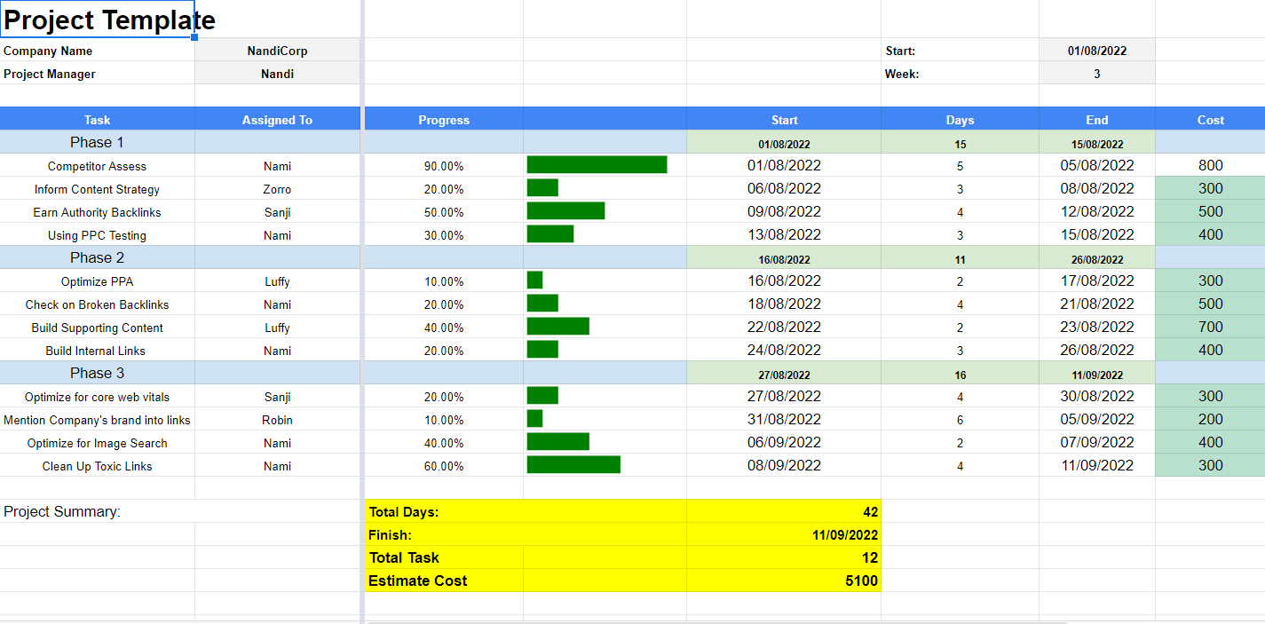

* Gantt Chart

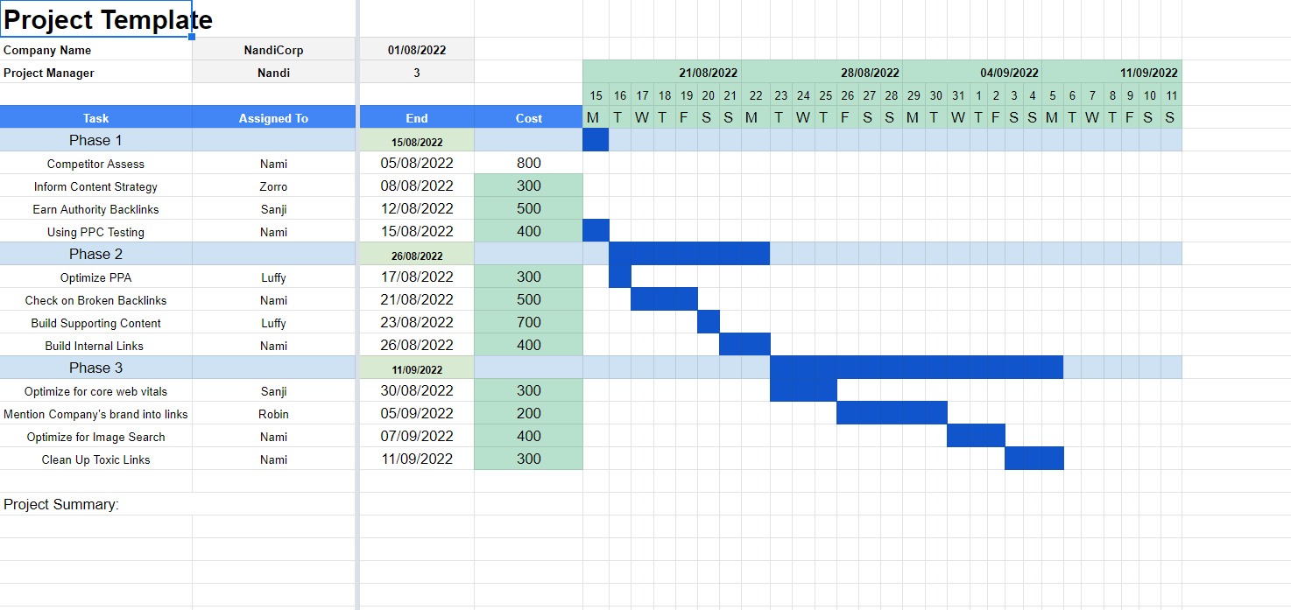

* Project Deliverable

The project is already on the move

* Communication plan

Held a meeting together with the stakeholders and note down the crucial things

* Risk Management

Risk management planning

• Describes the risk management process in the project

• What has to be communicated?

• What kind of meetings are needed?

• Which tools, documents etc. are used?

• First estimate of overall project risk

• Definition of risk categories

• Definition of key figures (e.g. for risk probability and impact)

• Schedule planning

* Risk identified

errors can occur on websites and some of them can cause your site to fall in rankings. Broken links, code errors and Javascript issues can prevent site statistics from getting to Google Analytics causing your site to take a nosedive.

With the right risk management practices, you can keep your site on the top of search engine pages. This article will discuss the importance of risk management and how to integrate it to ensure your site is visible.

This is the steps for identifying risk in SEO

• Start risk identification as soon as possible

• Iterative process. Repeat throughout the whole project

• Should be part of every status meeting

• Opens out into risk index

• First counteraction can be planned while conducting risk identification already

• Most urgent Most urgent risks are addressed addressed first

• Not later than kickoff the risk index must exist

* Contingency plan
* 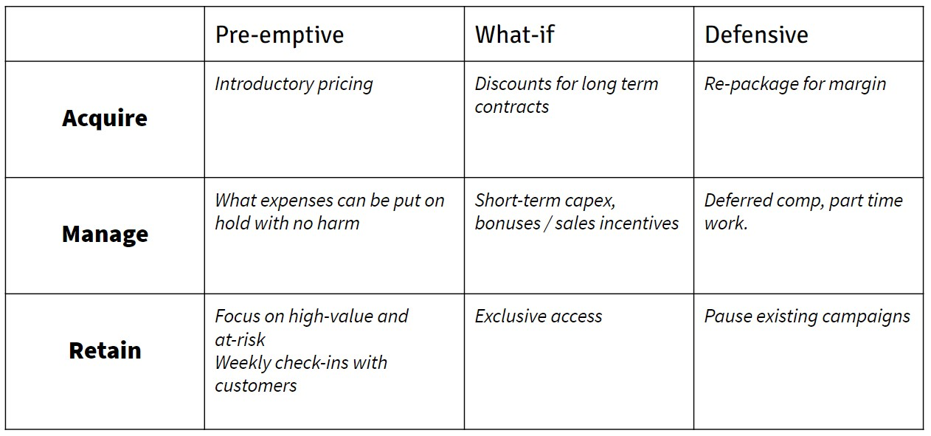

### 

### Task 5: Project Closure

Prepare project closure document template as following:

Project Sign off

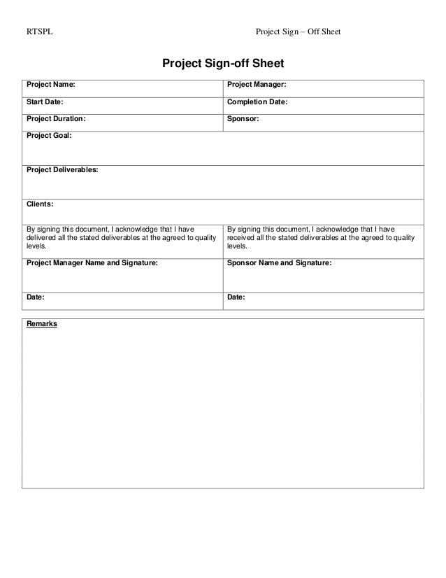

* Project evaluation document

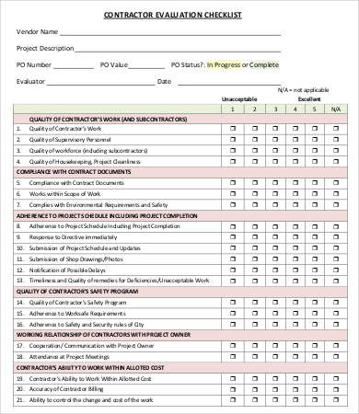

* Lesson learned template

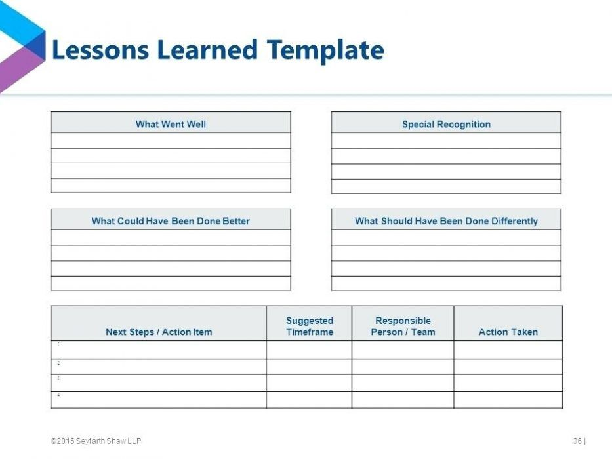

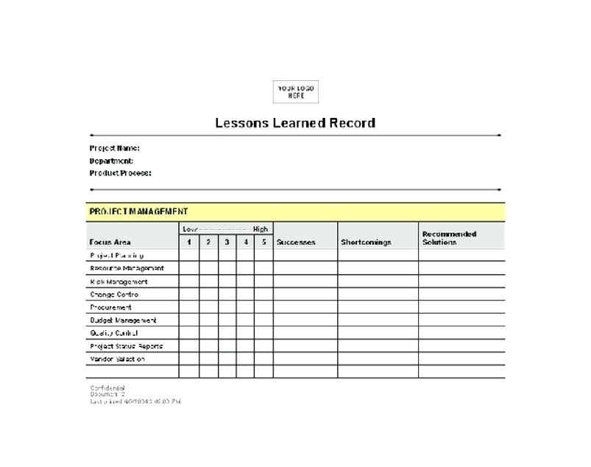

## Helpful web links to complete the assessment:

## Search Index

F

feasible solution 1, 5

H

hardware products 3

P

project sign off 9

S

same mistake 11

scenario 1

specific focus 2